**Ⅰ.　Introduction**

This year, the infection control measures have been settled and school life has almost returned to normal, with pupils and students enjoying a more active school life.

However, the depreciation of the yen and soaring costs are having a significant impact on GKA's unique educational activities, such as securing overseas teachers and overseas study tours, putting pressure on school management.

Nevertheless, the uniqueness of our school, which will be in its 20th year next year, is gaining recognition nationwide,

We will continue to hold information sessions in Tokyo and introduce our pre-school, with a view to the development of English language education in Japan.

**II. Outline of the Educational Bisiness**

**1 , Business in education activities**

**1) Elementary School**

①　Resumption of various events.

Various events that had been restricted were resumed. The Children's Bazaar allowed parents to visit the school and SHIP organised a festival. At the Winter Concert, students from Years 2, 4 and 6 and the Middle and Upper School presented their work in the Aeris Hall. We also reverted to the pre-Corona format of a whole school presentation of learning at the end of the year.

　②　Resumption of AUS short-term study abroad programmes.

The short-term study abroad programme for sixth-form students, which had been cancelled in Corona, has been resumed. The duration was two weeks and the students attended the local school while staying with one family.

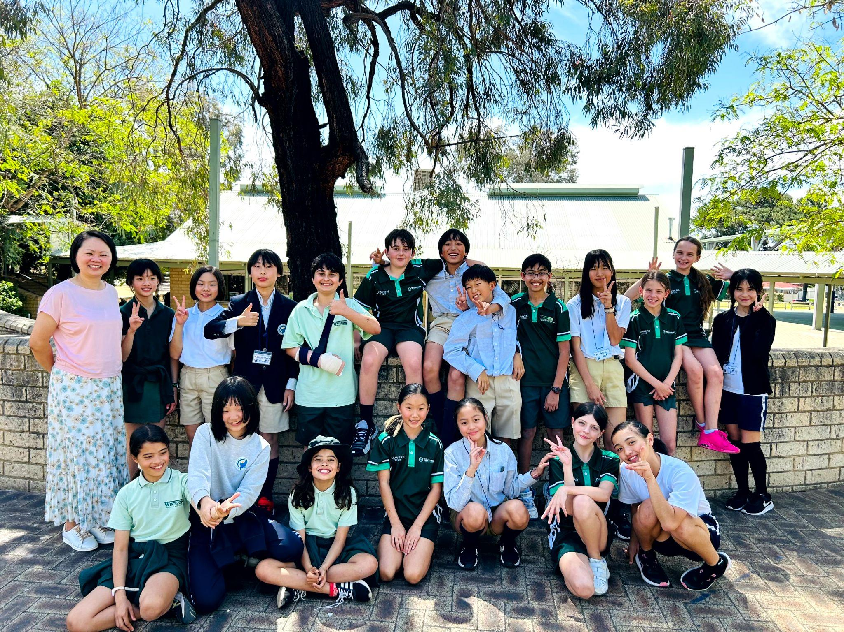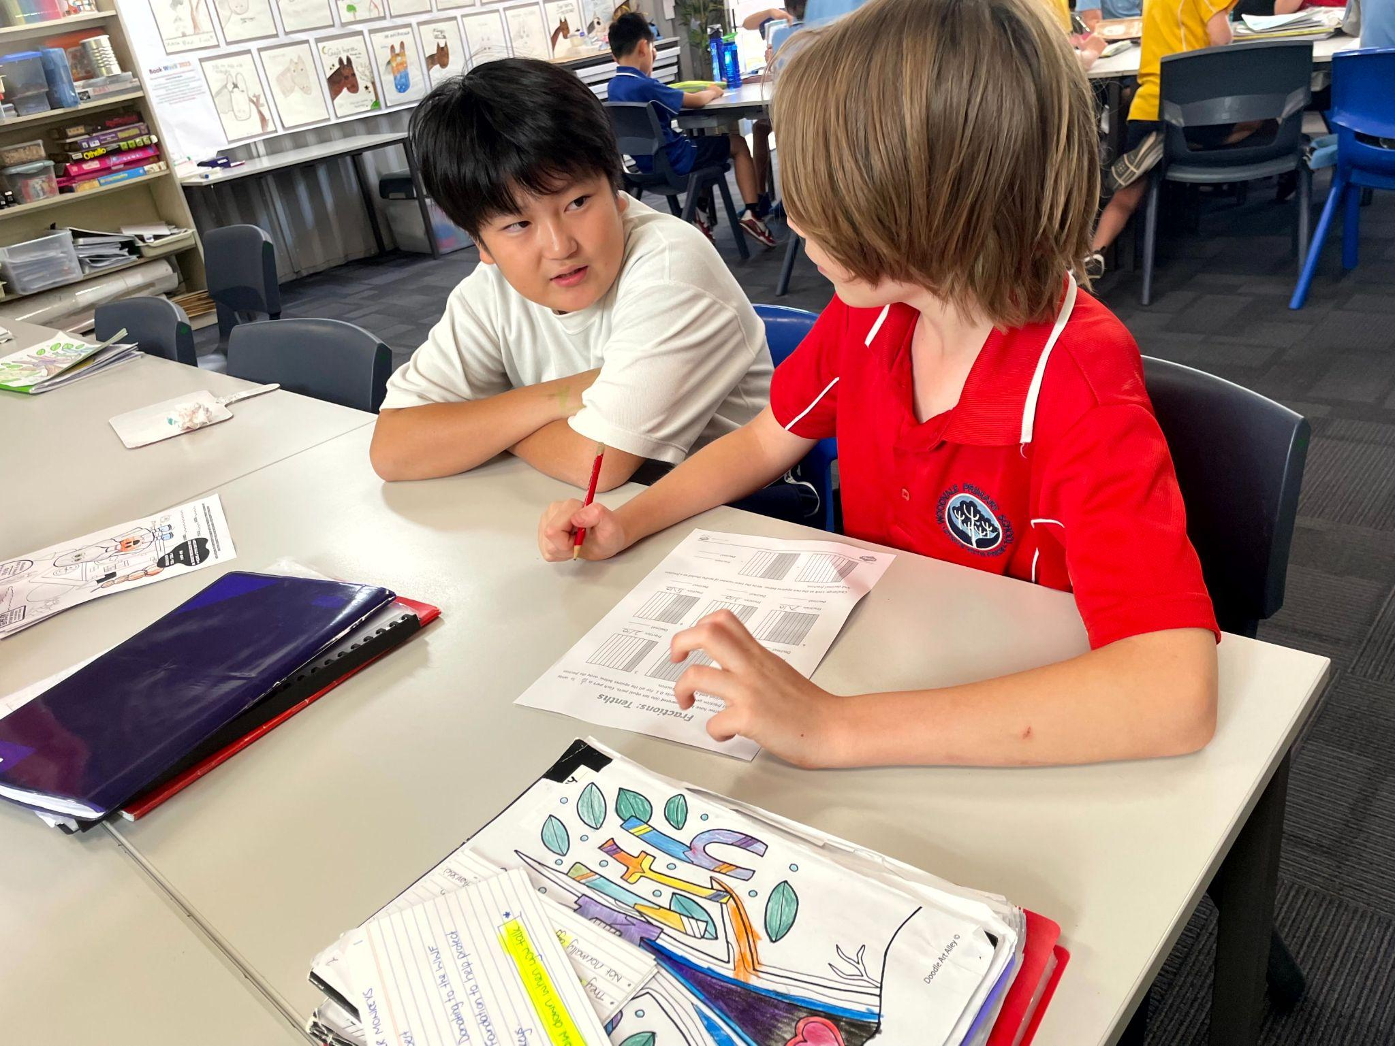

　　③　Due to the hotter weather in September, the Sports Day (Sports Day) was moved to early June. It was held simultaneously in all grades and there was no limit to the number of parents who could attend.

④The TOEFL Jr. High School standard score of 780 and the TOEFL Jr. Secondary standard score of 700, which was applied from last year, continued to be understood by parents, and measures were taken during the long holidays to provide opportunities to teach English grammar in Japanese to those who wished to take the test.

**２）　Junior High**

①　MYP education linked to IB/DP education was enhanced, and activities

that could not be implemented until last year, such as work experience,

were also carried out.

②　School trips were also resumed and domestic residential training

and other activities were resumed to diversify learning activities.

　　　③English language learning support programmes were also developed

for TOFLEJr780, and measures were taken to enable more students

to progress to higher education.

**3) Sinior High**

①　Revival of overseas educational programmes

　　　Efforts have been launched to enhance English language education at a higher

level by shifting from traditional overseas training, mainly through homestays,

to a more educational programme, with more training at overseas universities.

　　　②　Academic fairs.

　　　　The previous cultural festival and science fair were combined to enhance the school's presentation activities by making use of the uniqueness of the students

and to introduce GKA's educational activities to the local community and parents.

**2. Projects in ancillary activities**

1) Pre-school project activities

　GKA Gotenyama Preschool was opened in Shinagawa Ward, Tokyo, and publicity activities were launched to attract children in Tokyo and Kanagawa.

２）　After-school activities

　　　After-school classroom activities to enhance remedial activities for students aiming

to enter medical school and science and mathematics students.

3) Special project activities (IB)

This year, too, we were able to organise ‘IB programme information sessions

’ for middle and high school parents and primary parents with the help of SHIP

(Parents' Association), and more in-depth information sessions on the more

realistic characteristics of IB education and higher education at the “IB Study

Group for Fathers”.

**(1) Board of Directors**

　　　　Chair Masayoshi Shimizu

　　　　14 trustees (including 7 concurrently serving as directors) 2 auditors

**(2) Schools**

1. Gunma Kokusai Academy Elementary School

69-1 Nishihon-cho, Ota-shi, Gunma 373-0033

　 　　　　　　　　　　　　　Phone:0276-33-7711 Fax: 0276-33-7710

２. Gunma Kokusai Academy Secondary School

　　　　　　　　　 1361-4 Uchigashima-cho, Ota-shi, Gunma 373-0813

　　　　 　　　　　　　　　　　　　 Phone: 0276-47-7711 Fax: 0276-47-7715

**（３）Number of students (planned for 2025)**

|  |  |  |
| --- | --- | --- |
| elementary | secondary | Total |
| 589 | 479 | 1068 |

**(4) Number of Faculty Members (planned for April 1, 2024)**

|  |  |  |  |  |
| --- | --- | --- | --- | --- |
|  |  | foreign nationals | Japanese | tota[ |
| full-time | teachers | 61 | 60 | 121 |
| officers | 3 | 20 | 23 |
| part-time | teachers | 0 | 6 | 6 |
| officers | 2 | 19 | 21 |
| total |  | 66 | 105 | 171 |

Converted 7 club activity instructors as part-time staff

　【personnel trend】

|  |  |  |  |  |  |  |  |  |
| --- | --- | --- | --- | --- | --- | --- | --- | --- |
|  | teaching staff | | | | officers | | total | |
| foreign nationals | | Japanese | |
| 2024 | 2023 | 2024 | 2023 | 2024 | 2023 | 2024 | 2023 |
| elementary | 27 | 26 | 28 | 29 | 10 | 9 | 64 | 64 |
| junior high | 16 | 18 | 13 | 13 | 8 | 7 | 34 | 38 |
| secondary | 18 | 18 | 13 | 11 | 5 | 5 | 36 | 34 |
| total | 61 | 59 | 54 | 53 | 20 | 21 | 134 | 136 |

＊excludes part-time staff

**（５）Nationalities of Teaching Staff**

|  |  |
| --- | --- |
| Country | # |
| USA | 21 |
| UK | 7 |
| India | 5 |
| Australia | 1 |
| Canada | 6 |
| New Zealand | 2 |
| Philippines | 13 |
| Singapore | 1 |
| Bhutan | １ |
| Kenya | １ |
| Jamaica | 1 |
| Chili | 1 |
| Malawi | １ |
| Japan | ５4 |
| 合　計 | １15 |

　　　　　　　　　　＊2024年4月１日予定

＊As of April 1, 2024